1040 Worksheet
This worksheet is designed to help you understand your tax return. By answering the questions, you will begin to understand how your income tax is calculated, including what deductions or credits can reduce the tax you owe.
Look at your tax return from last year. You might have just a 1040 form, or it might have one or more schedules attached to it. Use it to answer these questions.
- Filing Status
Just below your name and address at the top of the 1040 is a section labeled Filing Status. What is your filing status?
__________________________________________
Your filing status along with your income will determine the rate of tax that you pay and whether you are eligible for many tax deductions. For example, a married couple filing jointly with $75,000 of income would pay a lower tax rate than a single person with the same amount of income. Another example is that a married couple gets a standard deduction (see #5) that is twice that of a single filer.

- Income
Lines 1 through 8 on the 1040 are each for different types of income. Which types of income did you have last year? If you have income shown on line 8, look at Schedule 1, Part 1 (Additional Income) to see what those other sources of income were. List each type of income that you receive below.

____________________________________
____________________________________
____________________________________
____________________________________
____________________________________
____________________________________

- Above-the-line deductions
If there is an amount on line 10 of the 1040, you have expenses that were deducted (subtracted) from your income. They are often referred to as “above the line” deductions because they are subtracted above the line where your adjusted gross income is calculated (line 11). These deductions are separate from the Standard Deduction or Itemized Deductions discussed in Question 5, below.

Check Part II of Schedule 1 to determine what expenses you were able to deduct. List the names of those deductions here.

_____________________________
_____________________________
_____________________________
_____________________________

- Adjusted Gross Income (AGI)
Line 11 on the 1040 is your Adjusted Gross Income (AGI). This income number is used in many different ways. For example, whether you qualify for the American Opportunity Credit, whether pay income tax on your Social Security benefits and whether you pay an Income-Related Monthly Adjustment Amount (IRMAA) for Medicare Part B and D are all determined by your AGI. How much was your AGI?
$ __________________________________

- Standard Deduction or Itemized Deductions?

Everyone gets to have some income that isn’t taxed. You get a standard deduction based on your filing status. Or, if you have certain types of expenses that add up to more than the standard deduction, you can itemize those expenses and claim the higher amount.

Look at Line 12 on your 1040. What is the amount of your deduction?
$ __________________________________
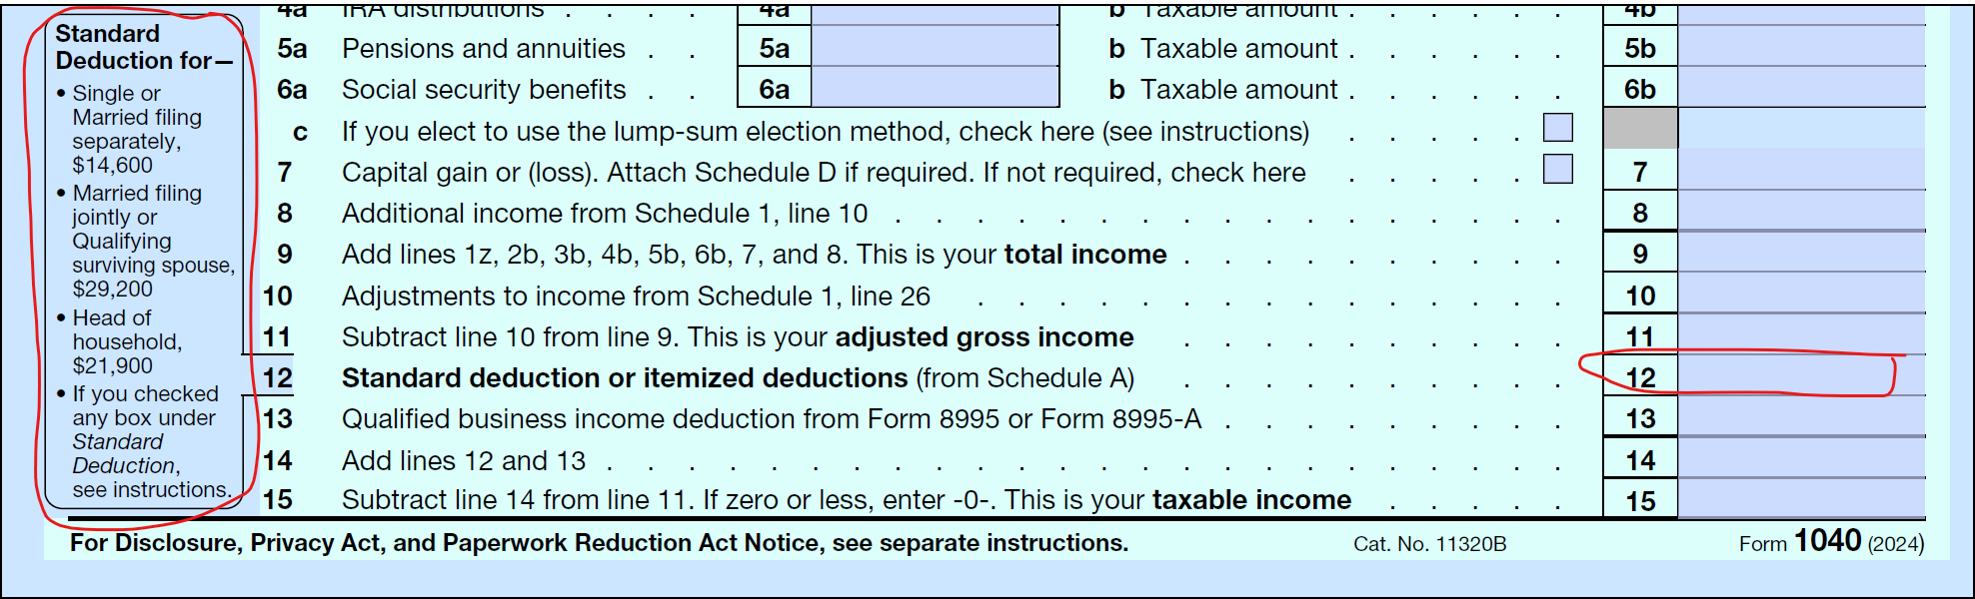
See the screenshot of this part of the 1040 below. If your amount in line 12 matches the amount listed in the left-hand column for your filing status, you took the standard deduction. If your amount is higher, you itemized, and you can see the expenses that qualified you for that bigger deduction on Schedule A.

If you itemized deductions, look at Schedule A. List the amounts you were able to deduct for each of these categories of expenses.
Line 4 – Medical & dental expenses $_____________
Line 7 – Taxes $_____________
Line 10 – Mortgage & $_____________
investment interest
Line 14 – Gifts to charity $_____________
Line 15 – Casualty & theft losses $_____________
Line 16 – Other misc. deductions $_____________
Notice that your deduction doesn’t always match the amount of your expenses. For example, for medical and dental expenses, see Line 3; you can only deduct expenses that exceed 7.5% of your adjusted gross income (AGI). And for taxes on line 7, the deduction is limited to $10,000 (line 5-e) even if your expenses totaled more than that.
- Taxable Income
Line 15 is your Taxable Income. This is the amount of income on which you actually pay taxes. You do not pay tax on all of your income. What is your taxable income?
$ __________________________________

- Tax Owed

Line 16 is the amount of income tax you owe. However, you may owe other taxes that are added in line 23. If there is an amount in line 23, look at Schedule 2 part II to see what those additional taxes were.
Line 16 – Tax $_____________
Line 23 – Other taxes $_____________ List other taxes: ______________
______________
______________
Line 24 – Total tax $_____________

- Tax Credits
Credits reduce the amount of tax you owe. These are listed in two sections: non-refundable credits in lines 19 and line 20 (see Schedule 3, Part 1 for details). Non-refundable credits will offset any tax that you owe. But if you owe no tax, you cannot get a refund for these credits.

Lines 27 to 29 and 31 (see Schedule 3, Part II for details) are refundable credits; even if you owe no tax, you can still get a refund for these amounts.

List any non-refundable credits you received
_____________________________________
_____________________________________
_____________________________________
List any refundable credits you received
_____________________________________
_____________________________________
_____________________________________

- Payments
This section totals all the money that was withheld from your paychecks, Social Security checks, and distributions from retirement accounts, etc. toward your taxes. If you made quarterly estimated tax payments or have refundable tax credits, those are included here as well.
List the amounts of those two types of payments here:
Withholding total from line 25-d $ _________________
Estimated tax payments line 26 $ _________________
You already listed your refundable credits (Lines 27 to 29 and 31) under Question 8.

- Refund or Amount You Owe
Did you get a refund, or did you owe money when you filed your taxes? See lines 35 and 37 on the 1040.
Refund: $ _____________ Owed: $ ______________
If you owe more than $1000, you might have to pay an underpayment penalty. You might want to increase the withholding from your paycheck, Social Security, or retirement income. Or you can pay quarterly estimated taxes.
If you get a large refund, you might want to reduce the amount withheld from your paycheck or other income.

